# Tester1 Sherry

Suggestions:

**main screen:**

this week events can be sort by categories

map maybe can be changed to other informations

**Post a new event:**

Special page needed to publish events (different categories, links video, description, date)

Offer location(uq map) of the events/activities in the posting event page.

**Reward System:**

giving voucher according to the level can be good

level maybe not sitimulate the user to participant events

level may cause potential competition among groups

# **Tester2 Constance suggestions:**

Problem: dont know how to find music clubs

maybe need time to learn and explore the app(design may not be straightforward enough)\

use uq Nav as the map tool(more interested participating in UQ activitives)

need a musical category for clubs

need to make the filter showed on the screen on default

think the “Free” sign is can be entered but not a button

comments function design is good and easy to find

task: add intereting tag

dont know where to customise the tags

# **Tester3 Emily**

(intereted in uq street dace club, looking for friends as companions)

Suggestions:

may want to use this app to find events and clubs as an intergrated platform

most of the users are familiar with swipping to explore the infomation

Version 2:event page

Cant not find how many people have already participant in the event

the design should be changed

Can not find the relation with boxing club(try to find the relation in the clubs page but it is in profile page)

# **Tester4 Bill**

Does not have a clear goal, simply going around the during market day and see if there is clubs and events that he might interested in.

Tasks: trying to find the free event in UQ

browsing through all the clubs to see if it has free events free or not. (Didn’t use filter)

think the button in the filter is not clickable

dont understand the fee graph

filter version one is better (simple and good to use)

Mail logo should change to bell logo

think the member relation graph is not useful(member list is more straightforward)

interface should be similar with “some” apps

like the rank and reward system which make the personal profile page interesting and engaging.(level system can be changed.)

# **Tester 5**

Interesting in other events but its information can only be told by friends

Would love to use this app if the app is popular used by all students

Event Page one:

Important!!! Event page “10/Free”. User don’t know it is free or not

Event page two:

the join button should not hide in the “+” button in the event page this make the user hard to join the event

Second filter is easier to use (people don’t want to add specific data about the date)

think the relation diagram is more appearing and should be the default form of the member list.

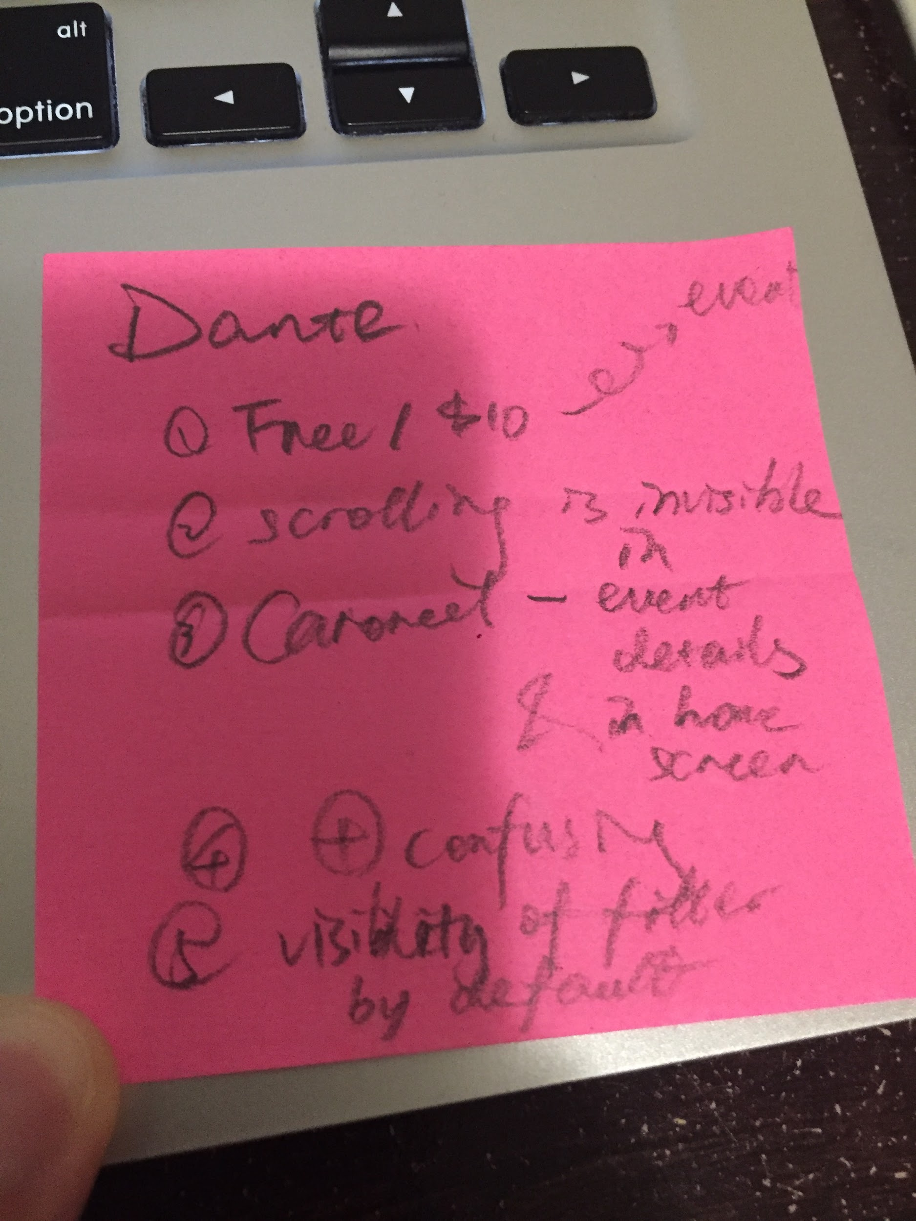

# **Tester 6**

Have participanted

Business social activities club

international vorlunteer club

chess club

was interested in some of these club and participated several events but gradually lost connection between those because of time issues and the events quality.

need a list or section to show liked events and can be seen by friends. Otherwise the LIke function does not do anything

can’t find the member list(didn’t know what the social map is member list)

need a section to store data for the event requirement for both users and organizers

think the image gallery is straightforward and interesting comparing to list format

facebook events information is limited and need to follow the event beforehand

our app is fexible to find and join the events.